PROJECT REPORT
Implement Client Script & UI Policy (Incident)
Team ID | SWTID-2026-5690
Project Name | Implement Client Script & UI Policy (Incident)
Team Lead | Rekha J
Team Member | Afrit Khan R
Platform | ServiceNow
Date | 04 October 2026

1. INTRODUCTION
1.1 Project Overview
This project improves the quality of data entered on the ServiceNow Incident form by adding a UI Policy and Client Scripts. The configuration runs in the browser and checks the information before a record is saved. When Impact is High, the UI Policy makes Assignment group mandatory and Urgency read-only; an onChange Client Script sets Urgency automatically; an onSubmit Client Script stops the save if Assigned To is empty; and an onCellEdit Client Script prevents State from being edited in the list view.
1.2 Purpose
The purpose is to make sure that high-impact incidents are complete and consistent when they are created, so that they reach the right group quickly, with less rework, and so that incident reports can be trusted. The project also demonstrates the correct use of declarative (UI Policy) and scripted (Client Script) controls on a ServiceNow form.
2. IDEATION PHASE
2.1 Problem Statement
The standard Incident form accepts incomplete and inconsistent data. High-impact incidents can be saved without an Assignment group or Assigned To, Urgency is set manually and often does not match Impact, and State can be changed carelessly from the list view. Errors are discovered only after the record is saved, which causes rework, delays resolution and weakens reporting.
2.2 Empathy Map Canvas
User: Service Desk Agent who logs and updates incidents.
SAYS | THINKS
"This incident is critical, who owns it?"  "Why was it saved without an owner?"  "I have to fix this record again." | "I must work quickly, there is a queue."  "I hope the form catches my mistakes."  "Which fields do I really have to fill?"
DOES | FEELS
Creates and updates incidents under time pressure.  Skips optional fields; edits State directly in the list.  Re-opens records to add missing owner or group. | Stressed by rework and rejected records.  Unsure which fields are required for High impact.  Relieved and confident when the form guides them.

PAINS | GAINS
Incomplete high-impact incidents  Urgency not matching Impact  Accidental State changes in the list  Errors found only after saving | Instant, clear messages on the form  Mandatory fields shown when needed  Consistent data and faster routing  Fewer returned or reopened incidents
2.3 Brainstorming
The team brainstormed ways to enforce data quality on the Incident form using Client Scripts and UI Policies, then prioritised them by value and effort.
No. | Idea | Type | Value | Effort | Priority
1 | Make Assignment group mandatory when Impact is High | UI Policy | High | Low | High
2 | Make Urgency read-only when Impact is High | UI Policy | High | Low | High
3 | Reverse the policy effects when Impact is no longer High | UI Policy | High | Low | High
4 | Auto-set Urgency to 1 - High when Impact is High, with a message | onChange | High | Low | High
5 | Block the save if Impact is High and Assigned To is empty | onSubmit | High | Medium | High
6 | Block State edits from the list view with an alert | onCellEdit | Medium | Medium | Medium
7 | Clear, friendly error and information messages | Messages | Medium | Low | Medium
8 | onLoad guidance banner on new incidents | onLoad | Low | Low | Low
9 | Filter Subcategory by Category | Client Script | Low | Medium | Low
10 | Server-side Business Rule as a backup for the same rules | Business Rule | High | High | Future
Ideas 1 to 6 were selected for implementation; ideas 7 to 10 are included as improvements or future scope.
3. REQUIREMENT ANALYSIS
3.1 Customer Journey map
Stage | Report | Enter details | Submit | Triage / assign | Resolve
Actions | Caller reports an issue; agent opens a new incident | Agent sets Impact and fills the form | Agent clicks Submit | Group and owner work the incident | Agent updates State and closes
Touchpoints | Incident form | Impact, Urgency, Assignment group | Submit / Update button | Incident list | Incident form, list view
Pain points (before) | Not clear which fields matter | Urgency set inconsistently; group forgotten | Saved without owner | Incident returned for missing data | State changed by mistake in list
Emotion | Neutral | Rushed | Unsure | Frustrated | Annoyed
How the solution helps | Form adapts to context | Group mandatory, Urgency set and locked | Save blocked with a clear error | Complete records route correctly | Alert protects State in list view
3.2 Solution Requirement
Functional requirements
FR No. | Requirement (Epic) | Sub requirement
FR-1 | UI Policy "High Impact Control" | Condition Impact is 1 - High; Assignment group mandatory; Urgency read-only; Reverse if false.
FR-2 | Urgency automation | onChange Client Script sets Urgency to 1 - High with an information message when Impact is High.
FR-3 | Save validation | onSubmit Client Script blocks the save and shows an error when Impact is High and Assigned To is empty.
FR-4 | List view protection | onCellEdit Client Script blocks State edits in the list view and shows an alert.
FR-5 | Testing & validation | Functional, performance and user acceptance tests with positive and negative cases.
FR-6 | Deployment | Configuration captured in an Update Set for migration to other instances.

Non-functional requirements
NFR No. | Requirement | Description
NFR-1 | Usability | Clear mandatory indicators and plain-language messages.
NFR-2 | Security | Role-based access; ACLs and Business Rules recommended as server-side safeguards.
NFR-3 | Reliability | Rules behave the same on every load, change and submit; no console errors.
NFR-4 | Performance | Lightweight scripts; responses appear immediately without a server round trip.
NFR-5 | Availability | Runs on the ServiceNow instance; no extra infrastructure.
NFR-6 | Scalability | Reusable on other tables and portable across instances with Update Sets.
3.3 Data Flow Diagram
Level 0: callers and service desk agents enter data on the Incident form; the form (with its Client Scripts and UI Policies) returns messages and alerts and passes validated records to the Incident table; the administrator configures the scripts and policies.
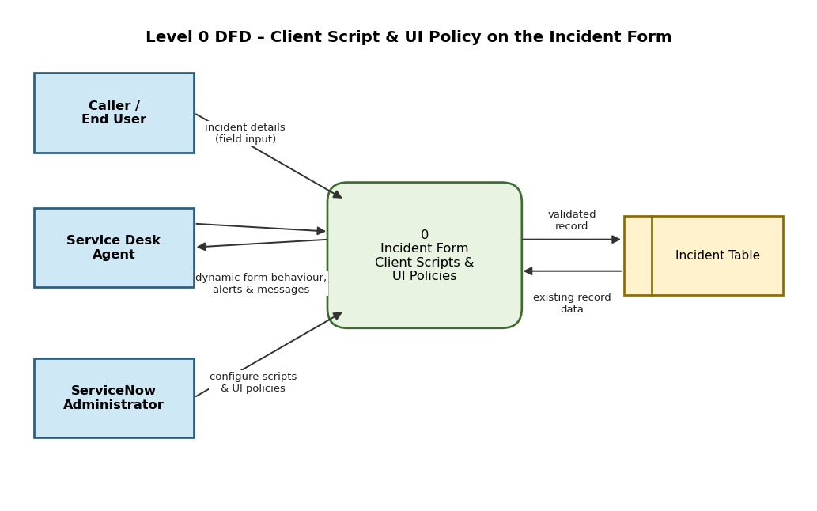
3.4 Technology Stack
Layer | Technology
Platform | ServiceNow (Personal Developer Instance)
User interface | Incident form and Incident list (ServiceNow web UI)
Declarative logic | UI Policy and UI Policy Actions
Scripted logic | Client Scripts in JavaScript: onChange, onSubmit, onCellEdit
Data | Incident table [incident]
Deployment | Update Sets
Testing | Manual UAT, user impersonation, browser developer console
4. PROJECT DESIGN
4.1 Problem Solution Fit
Canvas element | Summary
Customer segments | Service desk agents, callers, incident managers, administrators
Problem / job to be done | Capture complete, consistent incident data at the time of entry
Root cause | Static form; validation happens only after save; no enforced data standards
Available solutions | Manual checks, server-side rules only, written guidelines, static mandatory fields
Behaviour | Agents skip fields, change State in the list, return incomplete records
Triggers / emotions | Reopened incidents and poor reports; frustration before, confidence after
Our solution | UI Policy and Client Scripts that guide and validate the form instantly
Channels | Online: ServiceNow web UI. Offline: phone and walk-in reports entered by agents
4.2 Proposed Solution
No. | Parameter | Description
1 | Problem statement | Incomplete and inconsistent Incident data is saved and corrected later.
2 | Idea / solution | UI Policy "High Impact Control" plus onChange, onSubmit and onCellEdit Client Scripts.
3 | Novelty | Instant client-side feedback; no-code policy combined with targeted scripts; covers form and list view; only out-of-the-box features.
4 | Social impact / satisfaction | Faster routing of critical incidents, fewer mistakes, cleaner reports.
5 | Business model | Reusable configuration (Update Set) with no extra licence cost; can be offered as a packaged service by partners.
6 | Scalability | Runs on the platform; reusable on Problem, Change and Request; promoted with Update Sets.
4.3 Solution Architecture
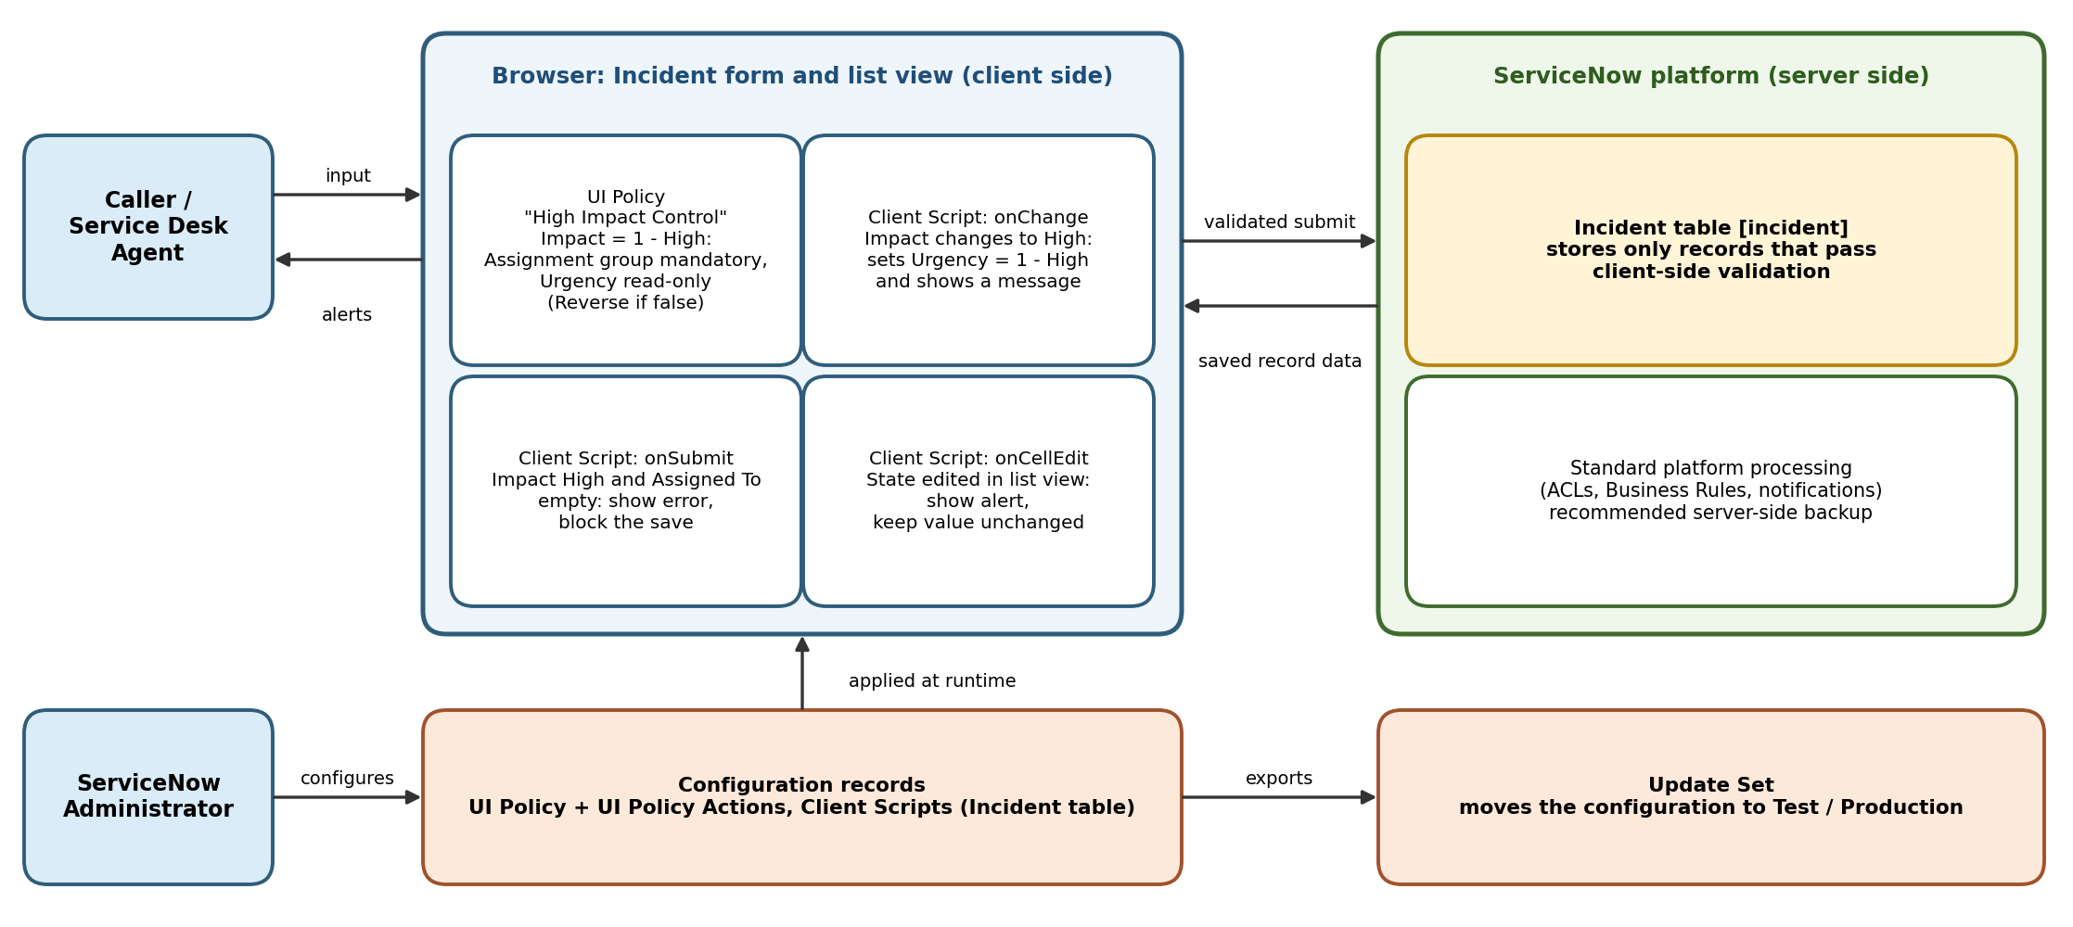
Figure 1: Architecture and data flow of the solution.
5. PROJECT PLANNING & SCHEDULING
5.1 Project Planning
Sprint | Epic | USN | User story / task | Points | Priority | Member
Sprint-1 | UI Policy | USN-1 | Create UI Policy with condition Impact is 1 - High | 3 | High | Afrit Khan R
Sprint-1 | UI Policy | USN-2 | Add actions: Assignment group mandatory, Urgency read-only | 2 | High | Afrit Khan R
Sprint-1 | UI Policy | USN-3 | Enable Reverse if false | 1 | High | Afrit Khan R
Sprint-1 | Client Scripts | USN-4 | onChange script: auto-set Urgency with a message | 3 | High | Rekha J
Sprint-1 | Client Scripts | USN-5 | onSubmit script: block save if Assigned To is empty | 3 | High | Rekha J
Sprint-2 | Client Scripts | USN-6 | onCellEdit script: block State edits in list view | 3 | Medium | Rekha J
Sprint-2 | Testing | USN-7 | Functional tests FT-01 to FT-04 | 3 | High | Afrit Khan R
Sprint-2 | Testing | USN-8 | Performance checks PT-01 to PT-03 | 2 | Medium | Afrit Khan R
Sprint-2 | Testing | USN-9 | User acceptance tests TC-001 to TC-009 and bug tracking | 3 | High | Both
Sprint-2 | Deployment | USN-10 | Update Set and documentation | 2 | Medium | Rekha J

Sprint | Story points | Duration | Start date | End date (planned) | Points completed | Release date
Sprint-1 | 12 | 6 Days | 05 Oct 2026 | 10 Oct 2026 | [ ] | [ ]
Sprint-2 | 13 | 6 Days | 12 Oct 2026 | 17 Oct 2026 | [ ] | [ ]
Velocity: (12 + 13) / 2 = 12.5 story points per sprint. Average velocity per day = 12.5 / 6 ≈ 2.08 story points per day. Completed points and release dates are filled in when each sprint closes.
6. FUNCTIONAL AND PERFORMANCE TESTING
6.1 Performance Testing
ID | Scenario | Test steps | Expected result | Actual | Pass/Fail
FT-01 | UI Policy: Assignment group mandatory and Urgency read-only for High impact | Create a new Incident and set Impact = 1 - High | Assignment group mandatory; Urgency read-only | [ ] | [ ]
FT-02 | UI Policy: Reverse if false | Change Impact from High to Medium | Mandatory removed; Urgency editable | [ ] | [ ]
FT-03 | onChange: Urgency auto-set | Set Impact = High on a new Incident | Urgency set to 1 - High with a message | [ ] | [ ]
FT-04 | onSubmit and onCellEdit validation | Submit High impact with Assigned To empty, then filled; double-click State in the list | Save blocked, then saves; list edit blocked with alert | [ ] | [ ]
PT-01 | Response time: Urgency auto-set | Change Impact to High and observe | Updates in under 1 second, no page reload | [ ] | [ ]
PT-02 | Response time: save validation | Submit with High impact and Assigned To empty | Error appears immediately | [ ] | [ ]
PT-03 | Response time: list edit alert | Double-click State in the Incident list | Alert appears immediately; value unchanged | [ ] | [ ]
Detailed user acceptance test cases (TC-001 to TC-009) and bug tracking are in the UAT document.
7. RESULTS
7.1 Output Screenshots
[Insert screenshot: Incident form with Impact = High showing Assignment group mandatory and Urgency read-only]
[Insert screenshot: information message after Urgency is auto-set]
[Insert screenshot: error message when saving without Assigned To]
[Insert screenshot: alert when editing State in the list view]
8. ADVANTAGES & DISADVANTAGES
Advantages
- Immediate feedback in the browser; errors are prevented rather than corrected later.
- Uses only standard ServiceNow features; no plugins, licences or integrations.
- UI Policy is reversible and easy for administrators to maintain.
- Portable between instances with an Update Set.
Disadvantages
- Client-side rules can be bypassed by APIs, imports and integrations unless server-side rules are added.
- Urgency does not reset when Impact is lowered (no else branch).
- Scripts must be kept lightweight and maintained as the form changes.
9. CONCLUSION
The project shows that a UI Policy and a small set of Client Scripts can make the Incident form guide users and protect data quality without any custom application. High-impact incidents now require an Assignment group and an owner, Urgency follows Impact, and State cannot be changed carelessly from the list. The solution is simple, fast and ready to be moved to other instances.
10. FUTURE SCOPE
- Add server-side Business Rules or Data Policies to enforce the same rules for APIs and imports.
- Reset Urgency automatically when Impact is lowered.
- Extend the pattern to Problem, Change and Request, and to the Service Portal and Workspace.
- Automate regression testing with the ServiceNow Automated Test Framework.
11. APPENDIX
Source Code
Sample scripts for the three Client Scripts (adjust names to match your instance):
onChange (table: Incident, field: Impact) – Auto set urgency for high impact
function onChange(control, oldValue, newValue, isLoading, isTemplate) {
if (isLoading || newValue === '') { return; }
if (newValue == '1') {
g_form.setValue('urgency', '1');
g_form.addInfoMessage('Urgency set to 1 - High because Impact is High.');
}
}
onSubmit (table: Incident) – Prevent save if Assigned To is missing for High impact
function onSubmit() {
if (g_form.getValue('impact') == '1' && !g_form.getValue('assigned_to')) {
g_form.addErrorMessage('Assigned To is mandatory for High impact incidents.');
return false;
}
return true;
}
onCellEdit (table: Incident, field: State) – Prevent state change via list edit
function onCellEdit(sysIDs, table, oldValues, newValue, callback) {
alert('State cannot be changed from the list view. Open the incident form to update it.');
callback(false);
}
Dataset Link
Not applicable. The project uses the standard Incident table of the ServiceNow instance.
GitHub & Project Demo Link
[Add your GitHub repository link and demo video link here]

